**Instruction and background:**

Lyme disease is the most prevalent tick-borne disease in New York State and is prevalent in the Northeast & Great Lakes region.

As illustrated by the map generated from data collected by the CDC:

Picture:<http://www2.erie.gov/health/sites/www2.erie.gov.health/files/uploads/picLymeMap.png>

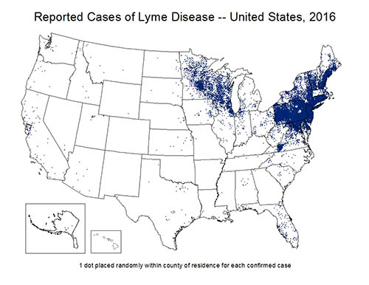

Ticks can infect humans and pets with bacteria, viruses, and parasites that can cause serious illness. And Lyme disease is an infection caused by the bacteria Borrelia burgdorferi and is spread to humans through the bite of infected blacklegged ticks (or deer ticks).

Infected deer ticks can be found throughout New York State.( Erie County, NY Department of Health).

For us living or studying in NY, getting a big picture of it can help us better prevent bites from ticks which include checking for ticks, showering after being outdoors and more.

This is my inspiration.

**Links to inspiring examples:**

(1)<https://health.data.ny.gov/Health/Community-Health-Lyme-Disease-Incidence-Rate-per-1/6sxr-cqij>

community health: Lyme disease incidence rate

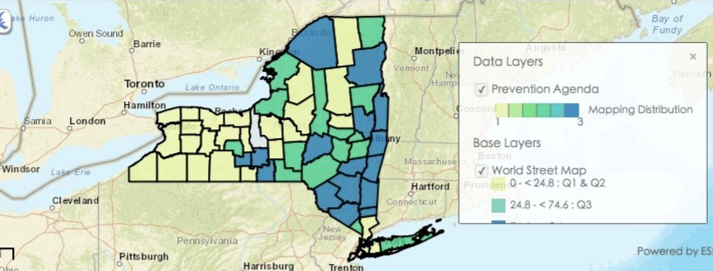

(2)positive Powassan virus pools detected by county.

<https://health.data.ny.gov/Health/Positive-Powassan-Virus-Pools-Detected-by-County-A/wqz2-r2ck>

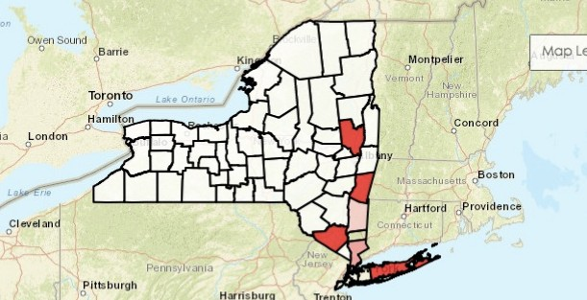

**Proposed data sources:**

(1)Deer Tick Surveillance: Adults (Oct to Dec) excluding Powassan virus: Beginning 2008:

<https://health.data.ny.gov/Health/Deer-Tick-Surveillance-Adults-Oct-to-Dec-excluding/vzbp-i2d4>

(2)

Community Health Lyme Disease Incidence Rate per 100000 by County

<https://health.data.ny.gov/Health/Community-Health-Indicator-Reports-CHIRS-Latest-Da/54ci-sdfi/data>

**Proposed methods:**

Library(ggplot2): making maps or charts

Library(dplyr):filtering, selecting or arranging data

Library(tidyr)dealing data

Library(sf):reading or converting spatial data

Library(sp)

Library(maps):

Library(maptools): getting or making map

**Expected result**:

There must be some connections between the deer tick and Lyme disease incidence rate. This project will Making thematic map and liner regression chart by the incidence of disease or by distribution of deer tick in different counties of New York. It can provide some connections.

Annotation: These data only provide adult tick infections at a precise location and at one point in time. Both measures, tick population density and percentage, of ticks infected with the specified bacteria or parasite can vary greatly within a very small area and within a county. This maybe causes some inaccuracies.